CHILLAGOE DISTRICT MINERALISATION – A TECTONIC MODEL

J. E. Nethery
Nedex Pty Ltd, 1 Eastern Street, Chillagoe, QLD 4871

Key words: Porphyry, skarn, gold, base metals, Alice Springs Orogeny, thrusts, transpression, transtension

ABSTRACT
Evidence is presented that NS compression related to the Alice Springs Orogeny circa 325Myr to 315Myr affected a large region of north Queensland including the Chillagoe district. Deformation and age dating indicates that the initial Mid-Carboniferous O’Brien’s Creek Supersuite intrusive and extrusive event spanned this deformation period and that gold mineralisation associated with retrograde alteration overprinting earlier prograde skarn was focused on thrust structures related to this deformation. Late Carboniferous to Early Permian dextral transtension circa 310Myr to 290Myr, with some 5km of throw is inferred to have dismembered a large porphyry gold system thus producing a series of tectonic slices of mineralised porphyry along a 7km zone of disruption known as the Red Dome Mine Corridor.

REGIONAL TECTONIC MODEL
Chillagoe is 150 km west of Cairns, and the district is located on one of the few exposed sections of the Tasman Line, marking the easternmost boundary between the Precambrian cratons and younger Tasmanides. The Red Dome and Mungana IRGS porphyry deposits and a multitude of other less well developed prospects, with mined and established resources of several million ounces of gold and accompanying base metals show strong evidence of pre-, syn- and post-depositional structural deformation through the Carboniferous to early Permian.

The Tasmanides regionally comprise the Palaeozoic Hodgkinson Basin – Broken River Basin System that has been variously described as a forearc accretionary prism (Henderson 1987), a backarc basin and an intra-continental rift (Bultitude et al 1993). The basin was long-lived and deformed by the Benambran deformation and a major Tabberabberan deformation. It is bordered to the west by the Palmerville Fault system, the regional surface expression of the Tasman Line. The fault bordered the edge of an imbricate thrust package inclusive of the entire Palaeozoic sequence including the Late Silurian to Early Devonian Chillagoe Formation. Modeling invoked overthrusting of the Proterozoic Georgetown Inlier towards the east and north east (Fawckner 1981; Shaw, Fawckner, and Bultitude (1987). More recently field mapping and geophysical modeling invoked an east-over-west inversion closure (Vos et al 2006). Neither satisfactorily explains all of the observed structural parameters. Later Hunter - Bowen deformation is recognised in the eastern sector of the Hodgkinson – Broken River Basin (Davis et al 2002) but lack of deformation in latest Carboniferous to early Permian stratified volcanics precludes its influence in the west of the basin around Chillagoe.

A Mid-Carboniferous deformation described as the Alice Springs Orogeny coincided with an abrupt change in velocity and direction of the Apparent Polar Wander Path, and the onset of the magnetic Kiaman Reverse Superchron circa 318Myr. ENE to ESE-oriented oroclines (megakinks), reverse faults and shallow thrusts developed throughout central Australia and the southern regions of the Tasmanides (Powell 1984). This deformation, although recognised in some areas of north Queensland (Withnall 1984, Hammond 1986), is not widely defined in recent tectonic literature. Mid-Carboniferous ENE-oriented oroclines and thrusting were invoked by Bell (1980) to explain the concept of a major convoluted linking structure involving the Palmerville, Burdekin, Clark River, and Millaroo faults, which he named the Big Bend Megafold. This interpretation rationalised major changes in orientation of the faults, foliation in the Siluro-Devonian plutons of the Georgetown Block, and foliations and folding in the Hodgkinson, Broken River, Burdekin and Drummond basins.

A revised model for this deformation was previously documented as extended abstracts but not published in full (Nethery and Barr 1996, Nethery 1999, Nethery 2004) and highlight a set of easterly-oriented oroclines, steep reverse faults, and shallow dipping thrusts indicative of north-south compression, which reinforce Bell’s megafolding model. Evidence extends over a wide north to south geographic spread from Cape Melville to the northern Drummond Basin (Figure 1). Noteworthy are shallow dipping mylonitic thrusts at Cape Melville (1) and Mt Mulgrave (5), shallow east-verging back-thrusts overprinting steeply dipping early Carboniferous inversion structures around Palmerville and Bellevue (4), asymmetric folding within and shallow thrusting at the base of the Carboniferous Boonmoo, Jamtin, Pratt (6) and Redcap (7) volcanic sequences, a high-grade metamorphic dome in the centre of the Georgetown Block (8), late Carboniferous EW folding in the Bundock Basin and Montgomery Range Igneous Complex (11), north-verging thrusting on the Clark River Fault (12), EW folding in the Burdekin Basin (14), shallow E-oriented thrusts in the Charters Towers Block (15, 16), NE-oriented oroclinal folding in the St Anne’s Salient of the northern Drummond Basin (20) and folding of the early phase of the Bulgonunna Group (17).

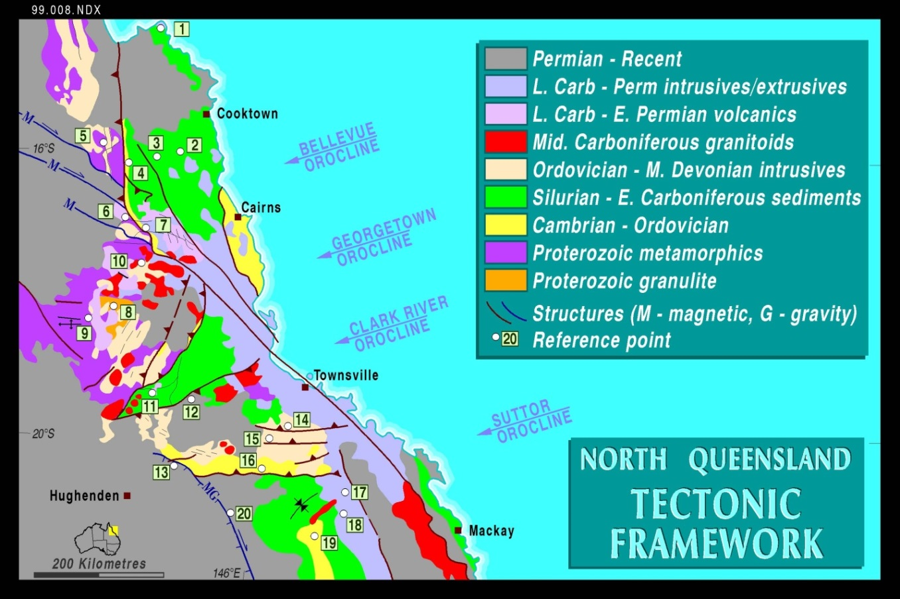

Figure 1: Simplified tectonic framework of northern Queensland with numbered features relevant to Mid- Carboniferous Alice Springs Orogeny deformation, involving NS compression.

The Alice Springs event waned, circa 310ma, and major dextral transtensional arcuate fault systems developed exemplified by the Neo-Palmerville, Dargalong, Gamboola, Robertson River faults, connecting through the St Lawrence, Millaroo, and Mt Perry faults to the dextral coupled Coffs Harbour - Texas Orocline (Murray 1987). The informal term Neo-Palmerville signifies the development of a dextral system along part of the now oroclinally folded Palmerville Fault. The change in both orientation and sense of movement of the regional torsion provoked collapse and diapiric rise of the SE-trending Late Carboniferous to Early Permian Kennedy Igneous Association, comprising fractionated oxidised to reduced, I-type and some A-type plutons, which extends from Mornington Island to Townsville (Mackenzie et al, 1994).

In the Chillagoe district 4 magmatic supersuites were defined, based on age and whole rock geochemical characterisation (Champion & Heinemann, 1994; Donchak & Bultitude, 1994).The Late Carboniferous supersuites are of I-type affinity, and span rhyolitic to andesitic compositions, whilst those of Early Permian age are of A-type affinity and are almost entirely rhyolitic (Mackenzie, 1987). The initial O'Brien’s Creek Supersuite (326-303 Myr, Mean 315Myr) comprises fractionated reduced I-type plutons and extrusive rocks, with associated tin, tungsten, molybdenum and gold mineralisation. The Ootann
Supersuite (306-299 Myr, Mean 300Myr) comprises fractionated reduced to oxidised I-type plutons and associated tungsten, molybdenum, bismuth, copper, lead, zinc and minor gold mineralisation. The Almaden Supersuite (303-292 Myr, Mean 300Myr) comprises fractionated reduced to oxidised I-type plutons and associated tungsten, molybdenum, bismuth, copper, lead, zinc mineralisation. The final Lags Supersuite (290-280 Myr, Mean 280Myr) comprises A-type plutons and extrusive rocks, and minor base metal sulphides and sulphosalts, uranium, fluorine, and minor gold mineralisation (Georgees and Nethery 2009).

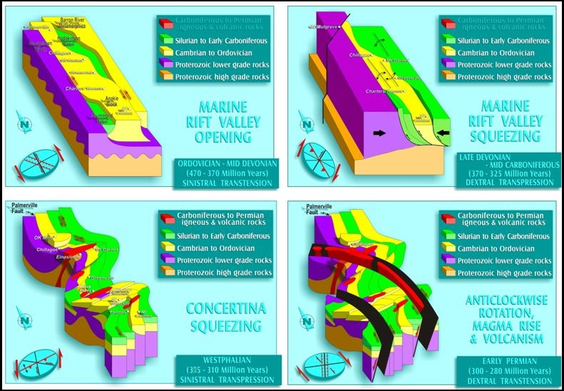
Figure 2: Schematic block models showing proposed tectonic stages through the Palaeozoic.

The initial Carboniferous magmatic suite, and associated extrusives including the O'Brien's Creek Supersuite, are pre-, syn- and post-kinematic, focused along the ENE- trending axes of the oroclines and are in part mildly deformed by the oroclinal folding event. This trend also applies to other mid Carboniferous granitic suites such as the Oweenee Granite, south of Greenvale, and the NE Drummond Basin granitoids, north of Mt Coolon. This is in contrast to the more voluminous Late Carboniferous – Early Permian intrusives and extrusives of the Kennedy Igneous Association which have a SE trend.
Steep reverse faults and shallow dipping thrusts/detachments of the Mid-Carboniferous event controlled sheeted veining, shallow dipping offsets, flatmakes, and disruption of intrusive plugs associated with coeval gold ± base metal mineralisation and have been noted at Red Dome, Mungana, Mount Wandoo, Anastasia, OK, Hodgkinson, Baal Gammon, Kidston, Croydon, Far Fanning, Ravenswood, Wirralie, Yandan and Pajingo.

CHILLAGOE MINERALISATION CONSTRAINTS
The Red Dome and Mungana deposits, 15km NW of Chillagoe, and nearby Redcap area give the most precise constraints on timing of the mid-Carboniferous deformation. The mines lie within a NW-trending belt of faulting and brecciation, informally called the Mine Corridor, in which most of the rock unit boundaries with competency contrast were subjected to shearing and mylonite development in the Late Devonian to Early Carboniferous thrust episode, and brittle faulting and brecciation in later episodes.

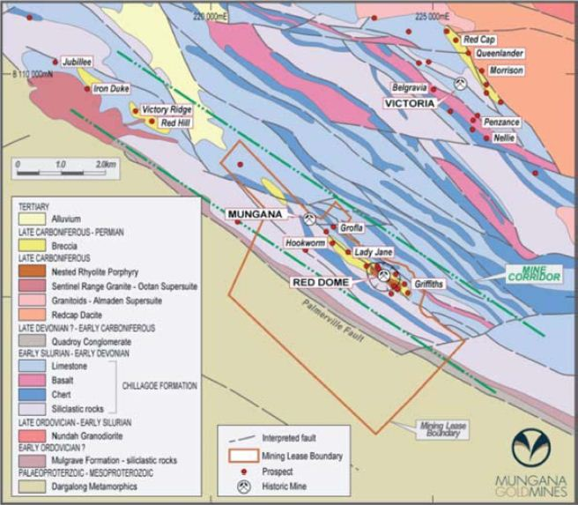

Figure 3: Red Dome Mine Corridor and environs with mine and prospects

Previous research identified a two-phase prograde skarn development at Red Dome, each with a late retrograde hydrous overprint (Torrey 1986; Ewers, Torrey, and Erceg, 1990). The skarn phases were called “brown garnet skarn” and “green garnet skarn” after the characteristic colour of the andradite. The skarns were confined to the periphery of the porphyry intrusives, but a widespread enigmatic pervasive potassic and propylitic alteration halo, too extensive to be related only to porphyry intrusives was noted.

The first retrograde phase is associated with shallow thrusting and steep reverse faulting, which had the effect of disrupting the quartz veined porphyry and brown garnet skarn, prior to the second green garnet skarn phase (Figure 4). This retrograde phase produced the auriferous mesothermal quartz veins. These faults then became the focus for the second stage green garnet skarn development, which commonly shows a regular subhorizontal layering within marble blocks. A third mineralising phase related to fine grained rhyolitic aplite ranged from minor low-sulphidation epithermal colloform quartz-adularia veining at depth, through massive sulphide-sulphosalt, chaotic and partly sub-horizontally laminated breccia pipe deposits, to highly oxidised clay-rich hydrothermal eruption breccias, sinters and chalcedonic silica caps near surface (Nethery and Barr 1998).

Post-mineralisation faulting further complicated the already complex structural picture. Dextral transtension reactivated the earlier compressional faults to produce SE to east-oriented dextral slip, north-oriented normal faulting, and detachment sliding on the shallowly-dipping former thrusts.

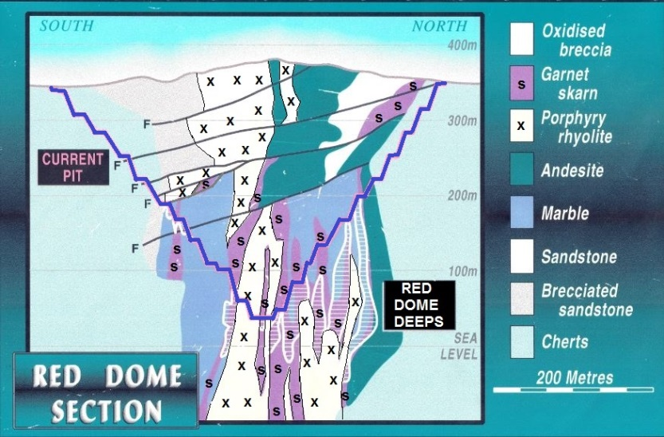

Figure 4: Typical Red Dome SW to NE cross-section with thrusts

overprinting the earlier steep structural fabric and porphyry.

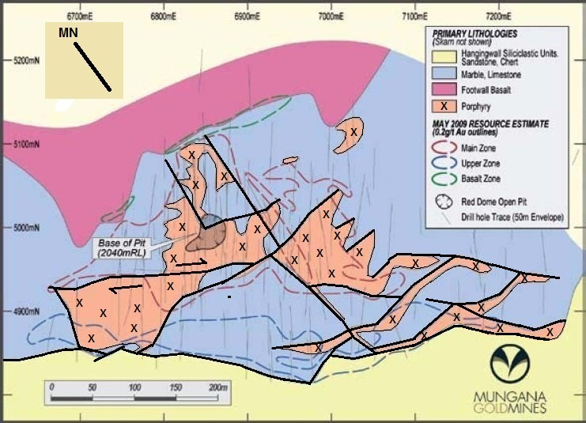

Figure 5: Red Dome plan view with interpreted steep faulted Boundaries of porphyry.

At Red Dome, two porphyry phases are present: An early quartz veined porphyry, and a later crowded porphyry which appears to have intruded along faults within the early porphyry. SHRIMP U-Pb dating of zircon from a quartz veined porphyry dyke produced a zircon crystallisation age of 325 Myr (range 330 to 310 Myr) (Perkins et al. 1995). K-Ar dating of sericite produced an argon retention age of 310 Myr (range 314 to 306 Myr), which indicates a minimum age for formation of sericite in this system. Two phases of intrusive emplacement are therefore inferred; an early O'Brien’s Creek Supersuite phase, and a later Almaden Supersuite phase.

At Mungana the sequence is not so precisely determined. ⁴⁰Ar/³⁹Ar dating of sericite produced a retention age of 308.3 Myr (range 308 to 308.6 Myr) (Perkins et al. 1995), suggesting an Almaden Supersuite alteration event. K-Ar dating of sericite produced a minimum age of 291 Myr (range 284 to 298Myr). Whole rock geochemistry of the Mungana intrusive (Woodbury, 1994), combined with the inferred sericite resetting at circa 290 Myr, has implicated A-type intrusive activity (Lags Supersuite) in the late stages of the paragenesis, which agrees with the observed late hydrothermal brecciation. The only recognised porphyry plug has undergone reverse faulting which suggests that it was intruded prior to the 315 Myr deformation. The anomalously high tin concentration also suggests the presence of an intrusive of the O’Brien’s Creek Supersuite. This age anomaly is solvable only by assuming that the retrograde sericite alteration system, coeval with the 315 Myr deformation, cooled below the argon retention temperature at about 308 Myr, and that these particular domains within the system were protected from later 290 Myr resetting.

Recent U – Pb age dating by Laser Ablation ICP-MS reinforces the above results (Georgees 2007, Lehrmann 2012). The drill intersection of coarse grained, equigranular granite at depth of 1000m in the Mungana deposit reinforces this model. U-Pb dating of zircons from this intercept in which a total of 9 samples produced a weighted mean of 305Myr demonstrates that the granite is younger than the Mungana quartz porphyry in which 11 samples produced a weighted mean age of 325Myr. The granite age is comparable to the 303Myr age determined previously from the outcrop of the Sentinel Range Granite, 4km to the NW. Dating of Red Dome core further reinforced the earlier work of Perkins (1995). Quartz feldspar porphyry produced ages of 322Myr and 324Myr, while Re – Os dating on molybdenite from an auriferous quartz vein from this porphyry produced an age of 322Myr. A dacite porphyry produced an age of 310Myr thus reinforcing earlier interpretation of the two-phase intrusion and skarn system.

The Redcap area offers a timing constraint window on the mid-Carboniferous thrusting and folding (Figure 6). The Redcap Volcanics ignimbrite sequence is folded into an asymmetric syncline, in a similar manner to the Pratt Volcanics, 30km to the west, the nearby Jamtin Volcanics and the Boonmoo Volcanics, further east near Irvinebank (Nethery and Barr 1996). The steep dips had previously been attributed to caldera collapse. A recent U-Pb dating of 3 zircons from the Redcap dacitic ignimbrite produced an age of 321Myr (Lehrmann 2012) and on a series from the Boonmoo Volcanics was between 318 and 325Myr (Prof. Zhaoshan Chang JCU EGRU pers. comm.). The north-eastern base of the Redcap Volcanics is a thrust surface over Hodgkinson Formation and on the southern edge the Chillagoe Formation is thrust over the volcanics along the mineralised Redcap Thrust. Nearby the Belgravia Granodiorite has stitched the Redcap Thrust and a U-Pb zircon date on this intrusive was 309Myr. The Redcap Volcanics contain anomalous levels of tin and sheeted and stockwork auriferous quartz veins, suggesting association with O’Brien’s Creek Supersuite.

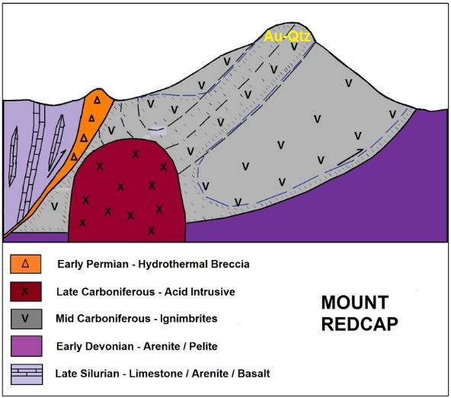

Figure 6: Redcap and Mount Redcap showing folding of ignimbrite sequence and thrusts.

Interpretation of regional airborne magnetic data shows a correlation of high magnetic intensity with magnetite bearing skarn and potassic alteration halo of the 2 km² exposure of a multiple phase intrusive, the Sentinel Range Igneous Complex, some 5 km NW of Mungana. This is the peak intensity area within a regional 50 km² anomaly, interpreted as an original elliptical shape, but with a superimposed system of anastomosing strike-slip faults (Figure 7). It has been difficult to rationalise the wide distribution in the Mine Corridor area of pervasive potassic biotite, propylitic chlorite + magnetite and phyllic quartz + sericite alteration, in terms of the size of the known porphyry intrusives. It was proposed that the entire area is underlain by a large younger pluton, and that the small intrusive plugs at Red Dome and Mungana were pre-existing pipe-like porphyry bodies, focused on the strike-slip faults (Nethery and Barr 1998). A combination of geological mapping and interpretation of airborne magnetic patterns was used to predict relative strike slip movement on the major faults throughout the mineralising period from 320 Myr to 280 Myr. This model predicts 5 km of dextral slip since intrusion of the O’Brien’s Creek Supersuite circa 324 Myr, and 2 km since 280 Myr, and therefore suggests that Red Dome, Mungana, Red Hill and deposits in between such as Girofla and Lady Jane may be faulted slices of a dismembered large porphyry system at the time of the main gold deposition.
The drill intersection of coarse grained, equigranular granite at depth of 1000m in the Mungana deposit reinforces this model. The U-Pb dating of zircons produced a weighted mean of 305Myr demonstrate that the granite is younger than the Mungana quartz porphyry which produced a weighted mean age of 325Myr (Georgees, C., 2007; Lehrmann 2012). The granite age is comparable to the 303Myr age determined previously from the outcrop of the Sentinel Range Granite, 4km to the NW in the centre of the magnetic anomaly.

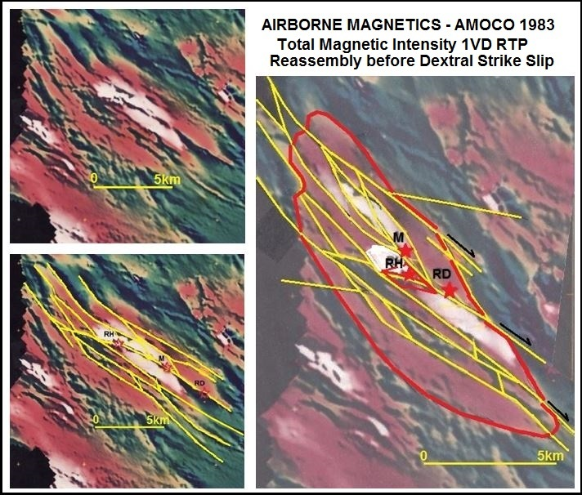

Figure 7: TMI 1VD RTP Aerodata McPhar survey 1983 for AMOCO Minerals Inc. Reprocessed 1993 by Niugini Mining Ltd. Interpreted reconstruction pre-Late Carboniferous transtension faulting.

CONCLUSIONS
NS compression related to the Alice Springs Orogeny circa 325Myr to 315Myr affected a large region of north Queensland including the Chillagoe district, producing oroclinal folding and thrusting. Deformation and age dating indicates that the initial Mid-Carboniferous O’Brien’s Creek Supersuite intrusive and extrusive event spanned this deformation period and that gold mineralisation associated with retrograde alteration overprinting earlier prograde skarn was focused on thrust structures related to this deformation. Late Carboniferous to Early Permian dextral transtension circa 310Myr to 290Myr, with some 5km of throw is inferred to have dismembered a large porphyry gold system thus producing a series of tectonic slices of mineralised porphyry along a 7km zone of disruption known as the Red Dome Mine Corridor.

ACKNOWLEDGEMENTS
This paper has benefited from the interaction with numerous colleagues, particularly Mike Barr, Charlie Georgees and Ian Morrison, over a 23 year period on the extended Red Dome project tenements. Tenement holder Atherton Resources Ltd is thanked for agreeing to this presentation.

REFERENCES
Bell, T. H., 1980. The deformation history of northeastern Queensland – A new framework. In Henderson, R A, & Stephenson, P J, (Eds). The Geology and Geophysics of Northeastern Australia. Geological Society of Australia, Queensland Division, Brisbane.
Bultitude, R. J., Donchak, P.J.T., Domagala, J., and Fordham, B.G., 1993. The pre-Mesozoic stratigraphy and structure of the Western Hodgkinson Province and environs, Queensland Geological Survey Record 1993/29.
Champion, D.C., and Heinemann, M.A., 1994. Igneous rocks of northern Queensland: 1:500000 map and explanatory notes, AGSO Record 1994/11.
Davis, B., Bell, C.C., Lindsay, M., and Henderson, R.A. 2002. A single late orogenic Permian episode of gold mineralization in the Hodgkinson province, north Queensland, Australia. Economic Geology, 97 (2). pp. 311-323.
Donchak, P.J.T., and Bultitude, R.J., 1994. Geology of the Atherton 1:250000 sheet area. Queensland Geological Survey Record 1994/5.
Ewers, G.R., Torrey, C.E., and Erceg, M.M., 1990. Red Dome gold deposit, in Geology of the Mineral Deposits of Australia and New Guinea (Ed F E Hughes), pp1455-1460 (Australasian Institute of Mining and Metallurgy: Melbourne).
Fawckner, J. F., 1981. Structural and stratigraphic relations and a tectonic interpretation of the western Hodgkinson province, northeastern Australia, Ph.D. thesis (unpublished) James Cook University of North Queensland, Townsville.
Georgees, C., & Nethery, J.E., 1999. The Mid-Carboniferous Tin – gold connection. In abstracts NE Queensland Mineral Exploration. AusIMM FNQ Branch Symposium November 1999.
Georgees, C., 2007. The Mungana porphyry-related polymetallic deposit. Bulletin of Australian Institute of Geoscientists No 46, 47 – 48.
Hammond, R.L., 1986. Large scale structural relationships in the Palaeozoic of northeastern Queensland: melange and mylonite development, and the regional distribution of strain, PhD thesis (unpublished) James Cook University of North Queensland, Townsville.
Henderson, R.A., 1987. An oblique subduction and transform faulting model for the evolution of the Broken River Province, northern Tasman Orogenic Zone. Aust. Journal of Earth Sciences, 34, 237 – 249.
Lehrmann, B., 2012. Polymetallic mineralisation in the Chillagoe district of north-east Queensland: insights into base metal rich intrusion-related gold systems. PhD thesis. James Cook University of North Queensland.
Mackenzie, D.E., 1987. Geology, petrology and mineralisation of the Permo-Carboniferous Featherbed Volcanics Complex, Northeastern Queensland, Proceedings Pacific Rim Congress 1987, pp. 297-301.
Mackenzie, D.E., Champion, D.C., and the AGSO - GSQ project team. 1994. Permian - Carboniferous magmatism and metallogeny in North Queensland - a new perspective. Extended conference abstract - New Developments in Geology and Metallogeny: Northern Tasman Orogenic Zone. EGRU, James Cook University of North Queensland, Contribution 50, pp 67-68.
Murray, C.G., 1987. Tectonic evolution and metallogenesis of the New England Fold belt, eastern Australia. Proceedings of the Pacific Rim Congress 87. Australasian Institute of Mining and Metallurgy, Melbourne, pp353 -358.
Nethery, J.E., 1999. North Queensland Tectonics – A Megawrench Model. Extended abstract. Proceedings AusIMM NQ Symposium, Cairns 1999.
Nethery, J. E., 2004. The IRGS – Orocline connection. A provincial scale tectonic indicator applied to north Queensland. In Northern Queensland exploration and mining 2004. Extended abstracts. AIG Bulletin No 40. May 2004.
Nethery, J E, and Barr, M, 1996. Revised late Palaeozoic tectonics of north Queensland. Geological Society of Australia Abstracts No. 41, 13th AGC, Canberra, 1996, p 313.
Nethery, J.E., and Barr, M.J., 1998. Red Dome and Mungana gold – silver – copper – lead – zinc deposits. In Geology of Australian and Papua New Guinean Mineral deposits (Eds: D A Berkman and D H McKenzie) pp 723 – 728 (The Australasian Institute of Mining and Metallurgy: Melbourne).
Perkins, C., Walshe, J.L., and Morrison, G., 1995. Metallogenic episodes of the Tasman Foldbelt System, eastern Australia. Economic Geology, 90,1443 – 1466.
Powell, C.McA., 1984. Terminal fold-belt deformation: Relationship of mid-Carboniferous megakinks in the Tasman fold belt to coeval thrusts in cratonic Australia. Geology, 12: 546 – 549.
Shaw, R.D, Fawckner, J.F., and Bultitude, R.J., 1987. The Palmerville Fault system: a major imbricate thrust system in the northern Tasmanides, North Queensland, Australian Journal of Earth Sciences, 34: 69-98.
Torrey, C.E., 1986. The geology and genesis of the Red Dome (Mungana) gold skarn deposit, north Queensland, MSc thesis (unpublished) James Cook University of North Queensland, Townsville.
Vos, I.M.A., Bierlein, F.P., Barlow, M.A., & Betts, P.G., 2006. The Palmerville Fault, NE Queensland, Australia: A multi-disciplinary approach to understanding major fault systems. Journal of Structural Geology, 28, 2097 – 2108.
Withnall, I.W., 1984. Stratigraphy, structure and metamorphism of the Proterozoic Etheridge and Langlovale Groups, central Georgetown Inlier, North Queensland. Geological survey of Queensland Record 1984 / 59.
Woodbury, M.J., 1994. Red Dome and Mungana porphyry Cu-Au and base metal skarns of North East Queensland. B.Sc.(Hons.) thesis (unpublished) Australian National University, Canberra.

